And Now, The Fake News: Proposal toStakeholders to Secure Investment in a Machine Learning-Driven Misinformation Classification Model

Zach Quinn

Bellevue University **The Problem**

In the past five years, the purposeful spread of misinformation has widened socioeconomic gaps, toppled democracies and incited physical violence. The proliferation of fake news makes detecting misinformation increasingly difficult. 64% of Americans surveyed by Pew Research expressed their belief that fake news has distorted their ability to trust verified information (Barthel, Mitchell, Holcomb, 2016). Annually, the dissemination of misinformation costs the global economy 78 billion dollars, contributing to an international stock market loss of nearly 39 billion dollars (Sullivan, 2019).

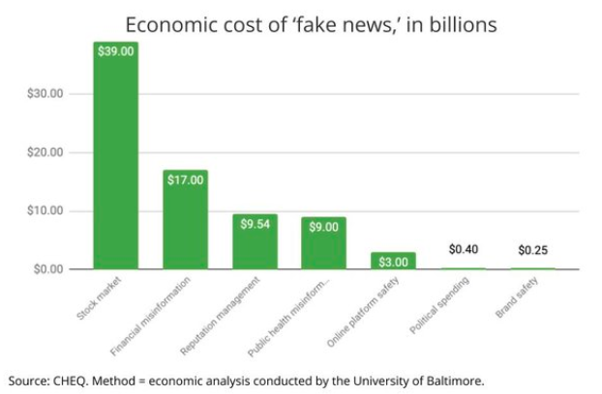

**Proposed Solution**

This project proposes a defense against the very real threat of misinformation: A machine learning model that splits a digital news story document into individual words and generates a report detailing how often the words appear, in order to make a binary determination whether or not a news story is most likely true or most likely fake. A model was trained to examine nearly 20,000 news stories in a classification data set derived from Kaggle. Using a TF-IDF vectorizer, a tool to reflect the importance of an individual word relative to the overall published text, four pipelines were developed to evaluate the model using a Passive Aggressive Classifier, a Naïve Bayes classifier, logistic regression, and a support vector machine. The initial hypothesis was that Naïve Bayes, given its ubiquity as a textual data classifier, would be able to make the most effective predictions on such a data set.

**Results**

Overall, the support vector machine was able to more consistently classify a story as true or fake relative to the test set (96% of the time), while the Naïve Bayes classifier was unable to do so (69 – 70% of the time), resulting in a rejection of the original hypothesis. An initial target metric of accuracy was abandoned because a model’s accuracy can be an arbitrary metric, especially in larger data sets. Instead, Python generated confusion matrices and classification reports that provided deeper insight into the model’s ability to precisely compare and recall information relative to the overall test set. Therefore, in examining the below classification reports, the most important metrics to be aware of are the ‘precision’, ‘recall’ and F-1 labels.

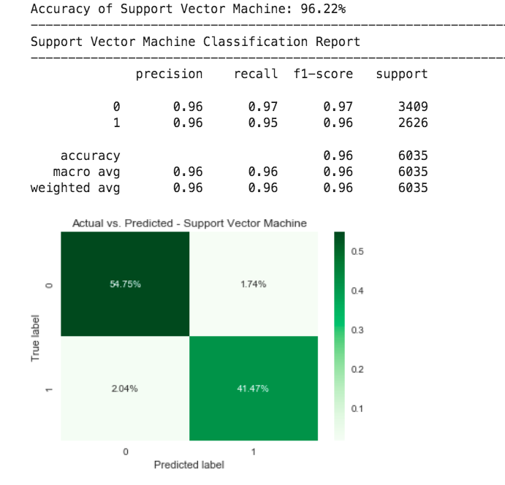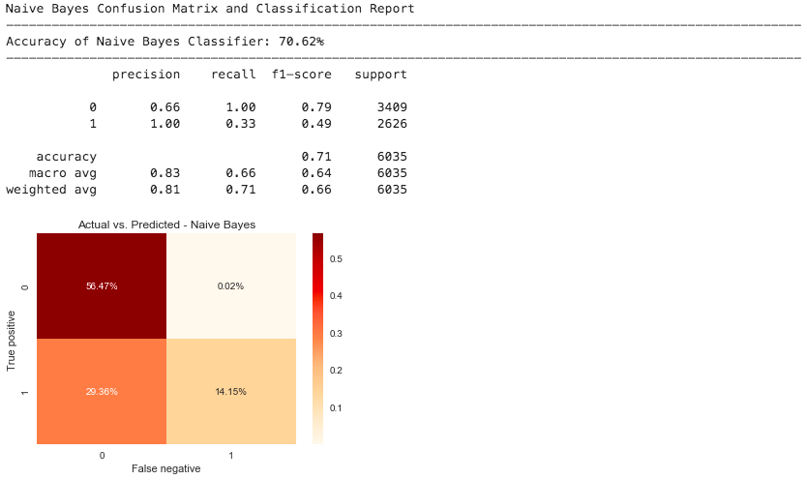

Misinformation is not only a problem during election years and has, in fact, increased with the global health crisis. Now, more than ever it is imperative to devote venture capital to creating tools to combat an information epidemic that undermines progress in the fight against COVID-19 and threatens to further divide politicized populations. The scope of human language, intent of expression and plethora of media outlets makes classification a difficult problem to solve, but one that must be addressed in order to protect the same freedom of speech that fuels misinformation and threatens increasingly volatile democracies like the United States.

**References**

Barthel, M., Mitchell, A. & Holcomb, J. (2016). Many Americans Believe Fake News Is Sowing Confusion. *Pew Research Center: Journalism and Media*.

Sullivan, L. (2019). Study finds ‘Fake News’ Has Real Cost: $78 Billion. *Search and Performance Marketing Daily*. Retrieved 8 August 2020 from: <https://www.mediapost.com/publications/article/343603/study-finds-fake-news-has-real-cost-78-billion.html>